Steps to Import Issues (i.e., Tasks/Issues/Stories/EPIC etc.,) in Atlassian JIRA tool:

- Login to your JIRA account
- Click on "Create" option as shown below:



- User will get below the window. Click on "Import issues" option as shown below:

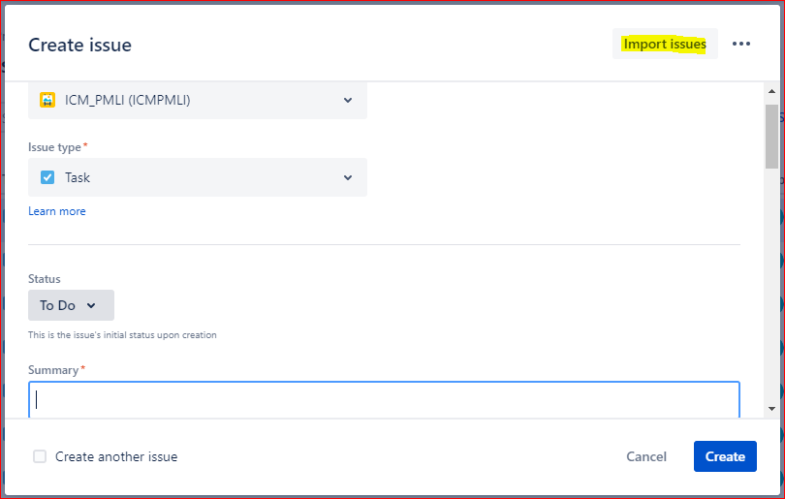

- User will see the "Choose File" option as shown below:

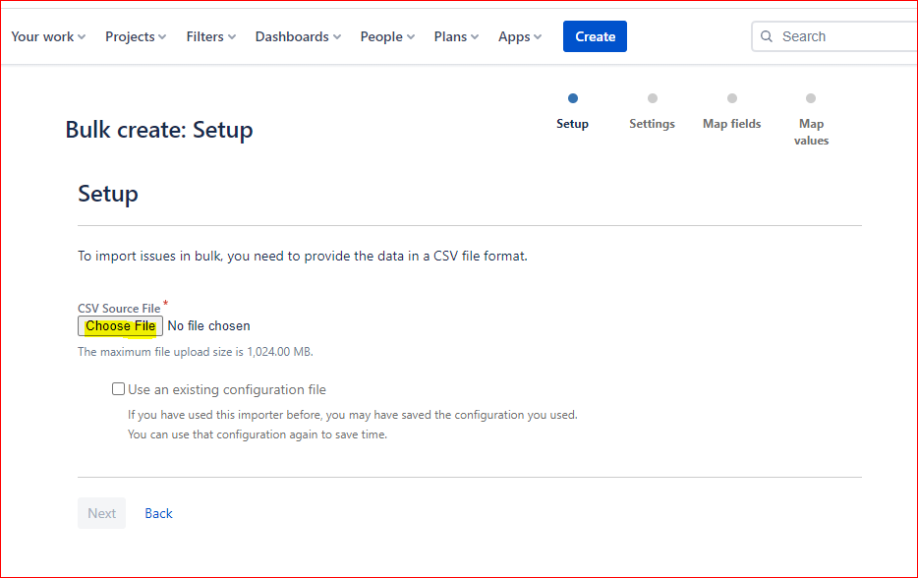

- Click on "Choose File" option and select your CSV File (wherein bulk issues are maintained by yourself) and click on "Next” as shown below:

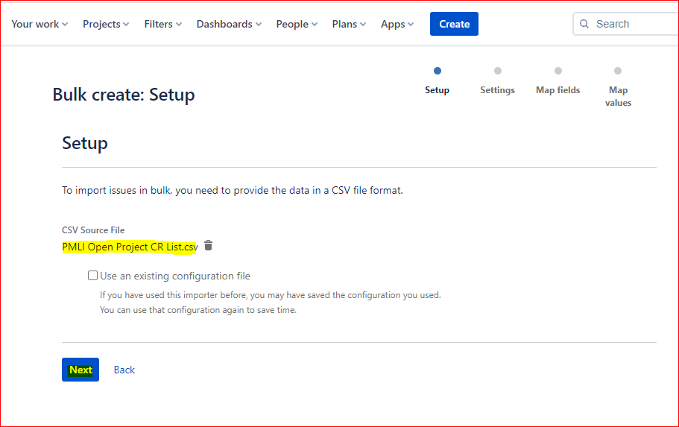

- User will get below window:

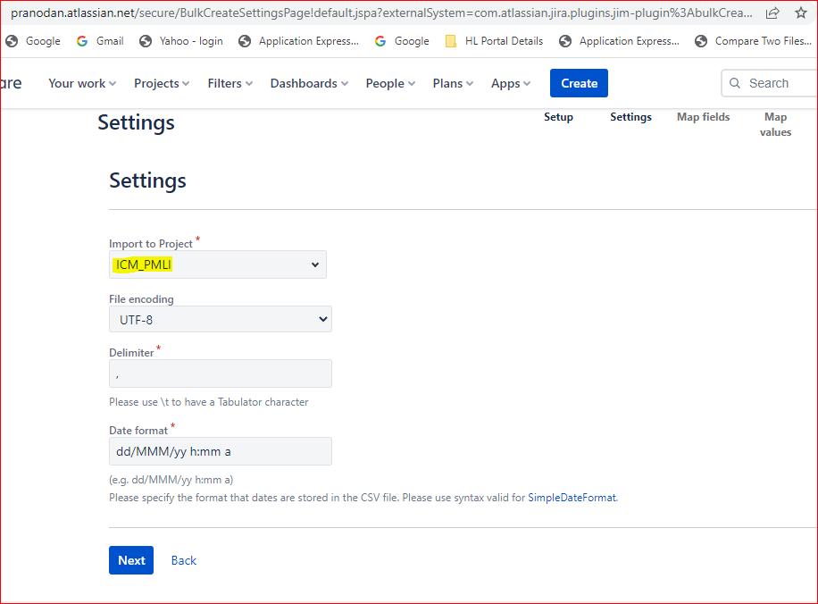

- Select appropriate Project name and click on "Next” as shown in above screenshot:

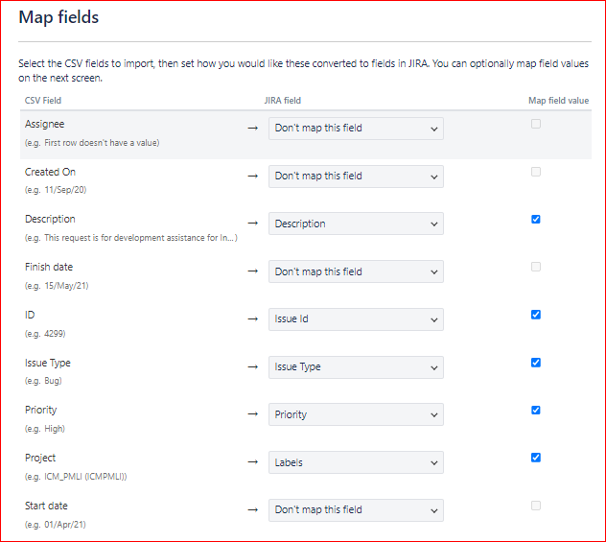

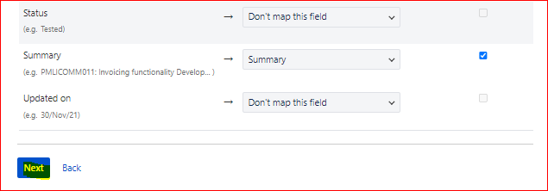

- Map your CSV Field with appropriate JIRA Field wherever applicable and then click on "Next" option as shown in above screenshots
- Post that user will see the below window:

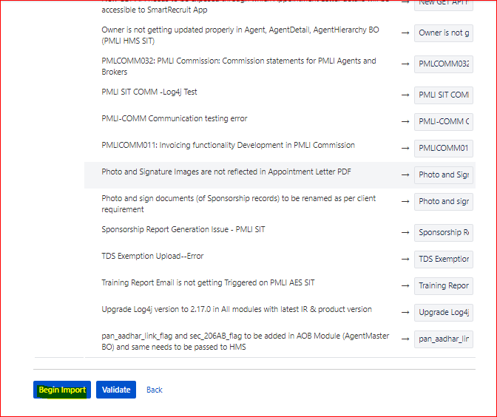

- Here, a user can Validate its mapping.
- In case the validation step is not required, kindly click on the "Begin Import" option as shown above.
- Post successful implementation, user will get the below message

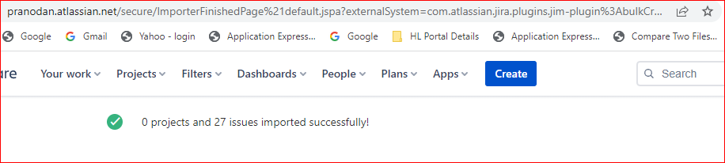

—------------------------------------------------------------------------------------------------------------

Note:
- To import issues (i.e., Tasks/Issues/Story/Epic etc.,) in a bulk process, we need to first maintain a data in CSV File
- I have used the below CSV file for storing details

https://drive.google.com/file/d/1Vm3jQ-MFpwKu3VUcTREDPBC6aQkr1Kxc/view?

- Below is the list of important fields on above CSV file:

CSV Field Name | Description
ID | CR ID / Open Project ID / Issue ID
Summary | CR / Issue details in short form
Description | CR / Issue details in detailed form
Issue Type | Bug / Story / Epic / Task etc., (i.e., Nature of ticket)
Status | To capture the latest Status information of that particular task (i.e., TO DO, DOING, DONE etc.,)
Priority | Priority of ticket (i.e., Highest, High, Low, Lowest)

- These details will help us to map CSV fields with appropriate JIRA fields during importing issues in JIRA

—------------------------------------------------------------------------------------------------------------

